Titanic Survival Prediction
Data set : https://www.kaggle.com/datasets/yasserh/titanic-dataset
Code :
#Task 1 :
import pandas as pd
import numpy as np
import matplotlib.pyplot as plt
import seaborn as sns
from sklearn.model_selection import train_test_split
from sklearn.preprocessing import LabelEncoder
from sklearn.linear_model import LogisticRegression
from sklearn.ensemble import RandomForestClassifier
from sklearn.metrics import accuracy_score, confusion_matrix, classification_report
# Load Dataset
df = pd.read_csv("Titanic.csv")
# Display first five rows
print("First Five Rows:")
print(df.head())
# Dataset Information
print("\nDataset Information:")
print(df.info())
# Missing Values
print("\nMissing Values:")
print(df.isnull().sum())
# Data Visualization
plt.figure(figsize=(5,4))
sns.countplot(x='Survived', data=df)
plt.title("Survival Count")
plt.show()
plt.figure(figsize=(5,4))
sns.countplot(x='Sex', hue='Survived', data=df)
plt.title("Survival by Gender")
plt.show()
plt.figure(figsize=(5,4))
sns.countplot(x='Pclass', hue='Survived', data=df)
plt.title("Survival by Passenger Class")
plt.show()
# Fill missing Age values
df['Age'] = df['Age'].fillna(df['Age'].median())
# Fill missing Embarked values
df['Embarked'] = df['Embarked'].fillna(df['Embarked'].mode()[0])
# Drop Cabin column if it exists
if 'Cabin' in df.columns:
df.drop('Cabin', axis=1, inplace=True)
# Encode categorical columns
le = LabelEncoder()
df['Sex'] = le.fit_transform(df['Sex'])
df['Embarked'] = le.fit_transform(df['Embarked'])
# Drop unnecessary columns if they exist
columns_to_drop = ['PassengerId', 'Name', 'Ticket']
df.drop(columns=[col for col in columns_to_drop if col in df.columns], inplace=True)
# Features and Target
X = df.drop('Survived', axis=1)
y = df['Survived']
# Train-Test Split
X_train, X_test, y_train, y_test = train_test_split(
X, y,
test_size=0.2,
random_state=42
)
lr = LogisticRegression(max_iter=1000)
lr.fit(X_train, y_train)
lr_pred = lr.predict(X_test)
print("\n===== Logistic Regression =====")
print("Accuracy:", accuracy_score(y_test, lr_pred))
print("\nConfusion Matrix:")
print(confusion_matrix(y_test, lr_pred))
print("\nClassification Report:")
print(classification_report(y_test, lr_pred))
rf = RandomForestClassifier(n_estimators=100, random_state=42)
rf.fit(X_train, y_train)
rf_pred = rf.predict(X_test)
print("\n===== Random Forest =====")
print("Accuracy:", accuracy_score(y_test, rf_pred))
print("\nConfusion Matrix:")
print(confusion_matrix(y_test, rf_pred))
print("\nClassification Report:")
print(classification_report(y_test, rf_pred))
importance = pd.DataFrame({
'Feature': X.columns,
'Importance': rf.feature_importances_
})
importance = importance.sort_values(by='Importance', ascending=False)
print("\nFeature Importance:")
print(importance)
plt.figure(figsize=(8,5))
sns.barplot(x='Importance', y='Feature', data=importance)
plt.title("Feature Importance")
plt.show()

Output :
First Five Rows:
PassengerId Survived Pclass \
0 1 0 3
1 2 1 1
2 3 1 3
3 4 1 1
4 5 0 3

Name Sex Age SibSp \
0 Braund, Mr. Owen Harris male 22.0 1
1 Cumings, Mrs. John Bradley (Florence Briggs Th... female 38.0 1
2 Heikkinen, Miss. Laina female 26.0 0
3 Futrelle, Mrs. Jacques Heath (Lily May Peel) female 35.0 1
4 Allen, Mr. William Henry male 35.0 0

Parch Ticket Fare Cabin Embarked
0 0 A/5 21171 7.2500 NaN S
1 0 PC 17599 71.2833 C85 C
2 0 STON/O2. 3101282 7.9250 NaN S
3 0 113803 53.1000 C123 S
4 0 373450 8.0500 NaN S

Dataset Information:
<class 'pandas.core.frame.DataFrame'>
RangeIndex: 891 entries, 0 to 890
Data columns (total 12 columns):
# Column Non-Null Count Dtype
--- ------ -------------- -----
0 PassengerId 891 non-null int64
1 Survived 891 non-null int64
2 Pclass 891 non-null int64
3 Name 891 non-null object
4 Sex 891 non-null object
5 Age 714 non-null float64
6 SibSp 891 non-null int64
7 Parch 891 non-null int64
8 Ticket 891 non-null object
9 Fare 891 non-null float64
10 Cabin 204 non-null object
11 Embarked 889 non-null object
dtypes: float64(2), int64(5), object(5)
memory usage: 83.7+ KB
None

Missing Values:
PassengerId 0
Survived 0
Pclass 0
Name 0
Sex 0
Age 177
SibSp 0
Parch 0
Ticket 0
Fare 0
Cabin 687
Embarked 2
dtype: int64
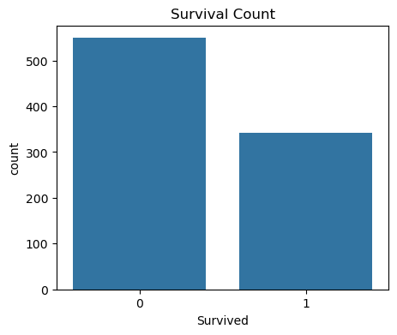
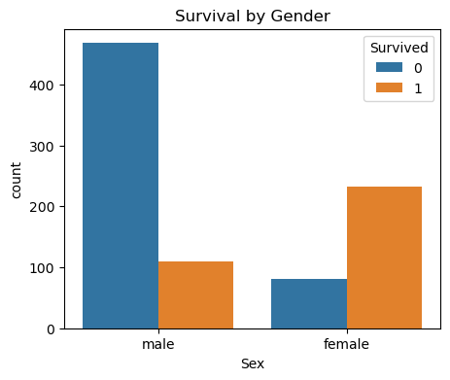
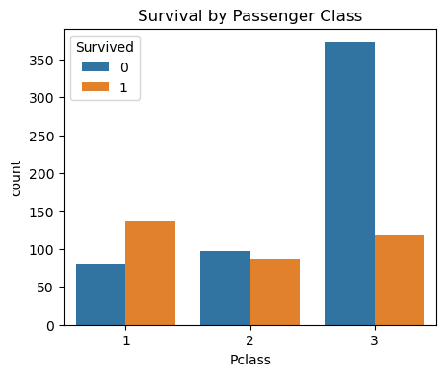

===== Logistic Regression =====
Accuracy: 0.8100558659217877

Confusion Matrix:
[[90 15]
[19 55]]

Classification Report:
precision recall f1-score support

0 0.83 0.86 0.84 105
1 0.79 0.74 0.76 74

accuracy 0.81 179
macro avg 0.81 0.80 0.80 179
weighted avg 0.81 0.81 0.81 179

===== Random Forest =====
Accuracy: 0.8212290502793296

Confusion Matrix:
[[92 13]
[19 55]]

Classification Report:
precision recall f1-score support

0 0.83 0.88 0.85 105
1 0.81 0.74 0.77 74

accuracy 0.82 179
macro avg 0.82 0.81 0.81 179
weighted avg 0.82 0.82 0.82 179

Feature Importance:
Feature Importance
1 Sex 0.271410
5 Fare 0.265010
2 Age 0.249995
0 Pclass 0.086957
3 SibSp 0.053685
4 Parch 0.039897
6 Embarked 0.033044
